A Project Report on

**Smart Garden Assistant**

**Submitted by**

**Ramanuja Phani Vishnu Teja Kandalam**

**&**

**Abhilash Valajipeta**

**Submitted to**



**as a part of**

**IB Hubs IoT Boot-camp ’18, Visakhapatnam**

**Date: 7th May 2018**

1. **Acknowledgement**

I am using this opportunity to express my gratitude to everyone who supported me throughout the course of this Make-a-thon project. I am thankful for their aspiring guidance, invaluable criticism and friendly advice during the project work. I am sincerely grateful to them for sharing their truthful and illuminating views on a number of issues related to the project.

Especially I would like to thank Ms.Kavya, Mr Manikantha, Ms.Anusha, Ms.Tanmay and Mr Atul for their support and guidance at **IB Hubs IoT Boot-camp ’18, Visakhapatnam.** I would like to thank Prof.Pallam Shetty Garu and especially our fellow participants for all the thoughtful and mind stimulating group interactions we had, which prompted us to think beyond the obvious.

1. **Abstract**

Internet of Things is going to be a revolution in the technology field. Various market opportunities and the rapid increase in a number of connected devices witness the growth of IoT. In this report, we have discussed IoT enabled Smart Gardener which updates concerned personnel the Soil moisture percentage thereby allowing them to water the plant only when required, optimizing usage of manpower, resources etc and also the plant which reacts to the human presence and reacts so that he/she could exactly feel the plant as part of their lives and take care of it.

We have also implemented a Nudge system, and control over these features remotely via a mobile app. We have made use of low-cost Wi-Fi module, an infrared sensor, Soil moisture sensor and cloud platforms for managing and processing sensor data. The main idea of this project is to make the plant a part of human life which helps them for happy and disease free life.

# Introduction:

# In the last few decades, we as human beings have experienced exponential growth in the technology in every walks of life. Even though the growth has been incredible it has also brought us it’s fair share of troubles along with it like Pollution of all kinds, Stress, Digital-disconnect and a plethora of health problems. Even the advanced medical services and tech are unable to rescue us. One such reason for these problems is the increase of the harmful gasses in the air and there are no purifiers for air which are in harmony with nature. And most of the air purifiers are not economical. Our endeavour is to develop technology to empower people with simple yet efficient tools to take charge of the environments they live in. And IoT is technology which finds its application in wide range of domains and has numerous applications. And our aim is to develop a Smart Garden Assistant which learns the requirements of the plant and notifies the user through the cloud technology and the plant can even respond to the living beings around it.

# The idea of this project is to make the plant interact with us like our fellow human beings so that it nurtures a healthy relationship and makes it a part of our life and make our surroundings *green, clean and healthy*. Sometimes the plants die due to the lack of water, in that case, the user may or may not know the exact requirement of the plant. Our project has a solution to this problem. We indicate the moisture level of the soil with the LEDs so that the user can easily understand the requirements of the soil and hence water it accordingly.

# Even when the owner is far away to the plant we can just send the notifications of the moisture level of that soil and warn us if the plant is out of the water. This helps us to easily take care of the plants which help in the growth of the plants thus leads to the green surroundings which lead to the green planet in which no people die due to air pollution.

# Approach

Fig 1: Block Diagram of the Project

# Hardware and Software components used

Hardware components include the following:

* Soil Moisture sensor: Soil moisture sensors typically refer to sensors that estimate volumetric water content.
* Ultrasonic Sensor: Ultrasonic Sensors measure the distance to the target by measuring the time between the emission and reception.
* Bread-board: A **breadboard** is a construction base for [prototyping](https://en.wikipedia.org/wiki/Prototype) of [electronics](https://en.wikipedia.org/wiki/Electronic_circuit)
* IB Hubs Octabrix development board,
* Connecting wires
* LEDs

Software components include:

* Blynk: Blynk is a Platform with iOS and Android apps to control Arduino, Raspberry Pi and the likes of the Internet.
* Arduino IDE: The open-source Arduino Software (IDE) makes it easy to write code and upload it to the board. It runs on Windows, Mac OS X, and Linux. The environment is written in Java and based on Processing and other open-source software.

# Features of the project

## Real-time streaming of Soil Moisture percentage

As soon as the Soil Moisture percentage of the plant is less than 20%, a notification will be sent to the smartphone of the owner along with the Soil Moisture percentage. There are 2 notification systems one uses mobile app notification and another is to alert with LEDs, where the LEDs indicate critical moisture levels of the plant.

The Human Interaction Module:

We are social beings. So it’s innate instinct that we want to spend with Interacting. Our aim is to Give Voice to the Life Around us especially plants. Our endeavour is to use the Ultrasonic sensor to detect the presence, soils moisture sensor to detect plant water needs. US sensor detects the motion around it and responds to it. Our Smart plant smiles when you or anyone come across it to spend some time with it. This feature makes the plant more interactive and the communication makes the plant a part of every human life.

## Motivational Nudges

On a periodic basis, the Plant nudges the owner with happiness boosting quotes to improve their mood and motivate them!

# Step by Step implementation

## Step 1: Interfacing Soil Moisture and US sensor to the Plant:

The soil moisture sensor is an analogue sensor which is used to get the percentage of the moisture in the soil. Its major scope is in the areas of the agriculture where the farmers can easily get the moisture values of their fields. Its analogue pin is connected to the A0 as input to the development board and this returns the analogue value which specifies the moisture content in the soil. In our prototype, we used moisture sensor as the component to identify the moisture in the pot so that the user can easily know the exact water requirement of the plant.

US sensor stands for Ultrasonic sensor we used this to read the presence of the subject with the set range of the around the plant.

## Step 2: Streaming the Soil Moisture percentage to a cloud platform:

We are using a limited service cloud platform called Blynk which is used for many IoT prototypes. By using this platform we can create a project and it has many widgets used to connect and control our prototype and that helps in the easy building of the prototype in an easy way. All we have to do is to log into Blynk and just connect our development board to the cloud using the authentication code sent by the Blynk to out google mail. We used the Blynk platform to send the moisture values of the soil to the user so that he/she could take better care of the plant.

## Step 3: Connecting the LEDs which are used to indicate the moisture content:

The other amazing feature of our project is that the user need not only rely on the Blynk app for moisture notifications but he/she can also use the LEDs placed with the plant to know the current moisture requirement of the plant easily. We used two LEDs which are green and red and used to indicate the soil moisture requirement. When the soil is drained out of the water the red LED blows up else the green LED blows up. By using this the user can get the idea of the moisture requirement of the soil easily by just looking at the plant itself.

# Hardware circuit diagram

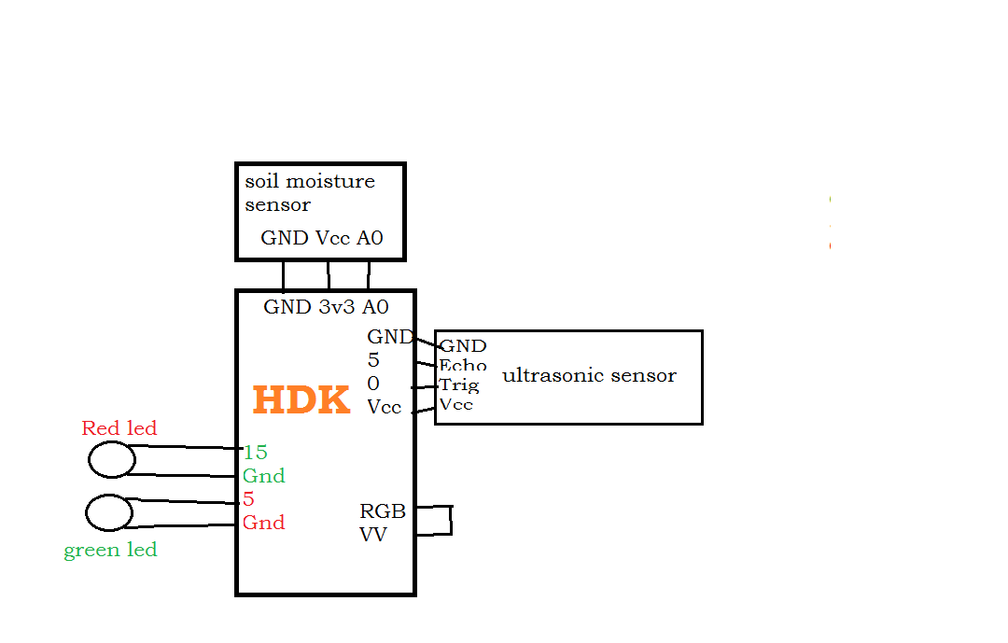

Fig 2: Hardware circuit of the Project

# Code

|  |
| --- |
| Smart Garden Assistant  #include "ESP8266WiFi.h"  #include <BlynkSimpleEsp8266.h>  #include <Adafruit_NeoPixel.h>  Adafruit_NeoPixel p(10,12);  const int trigPin = 0;  const int echoPin = 5;  long duration;  int i=0;  int distance;  BlynkTimer timer;  void setup()  {  pinMode(trigPin, OUTPUT);  pinMode(echoPin, INPUT);   Blynk.begin("4069a24a2e2a4a4a87ff34170d790fed","UTStarcom","9491802862");p.begin();  Serial.begin(115200);  pinMode(A0,INPUT);  timer.setInterval(12,hello);  }  void loop()  {   Blynk.run();  timer.run();  }  void hello()  {   p.setPixelColor(3,p.Color(50,50,50));   p.setPixelColor(5,p.Color(50,50,50));   int val=map(analogRead(A0),978,638,0,100);  digitalWrite(trigPin, LOW);  delayMicroseconds(2);  digitalWrite(trigPin, HIGH);  delayMicroseconds(10);  digitalWrite(trigPin, LOW);  duration = pulseIn(echoPin, HIGH);  distance= duration*0.034/2;  Serial.print("Distance: ");  Serial.println(distance);  if(distance >= 70)  {   if(i==0)  {   Blynk.notify("I MISS YOU");   i=1;  }  Serial.println("face on");     for(uint16_t i=0;i<255;i=i+5)    {       p.setPixelColor(0,p.Color(i,i,i));      p.setPixelColor(1,p.Color(i,i,i));      p.setPixelColor(9,p.Color(i,i,i));      p.setPixelColor(8,p.Color(i,i,i));      p.setPixelColor(7,p.Color(i,i,i));      p.show();  }  }  else  {   Serial.println("face off");   for(uint16_t i=255;i>=0;i=i-15)    {      p.setPixelColor(0,p.Color(i,i,i));      p.setPixelColor(1,p.Color(i,i,i));      p.setPixelColor(9,p.Color(i,i,i));      p.setPixelColor(8,p.Color(i,i,i));      p.setPixelColor(7,p.Color(i,i,i));      p.show();  }   i=0;   }   if(val<=20)  {   Blynk.notify("moisture too low");  }  } |
|  |
|  |
|  |

# 

# Final prototype C:\Users\user\Desktop\PHOTO-2018-05-31-20-51-41.jpg

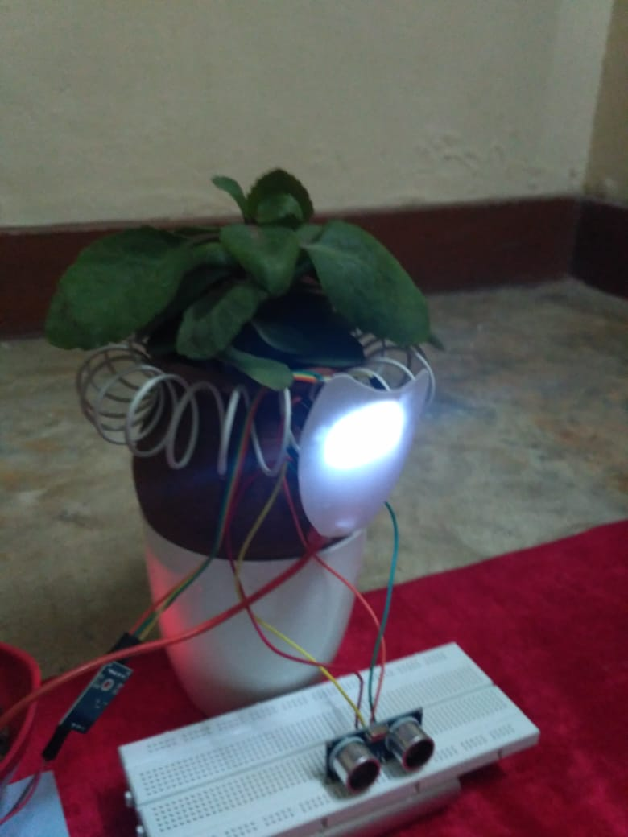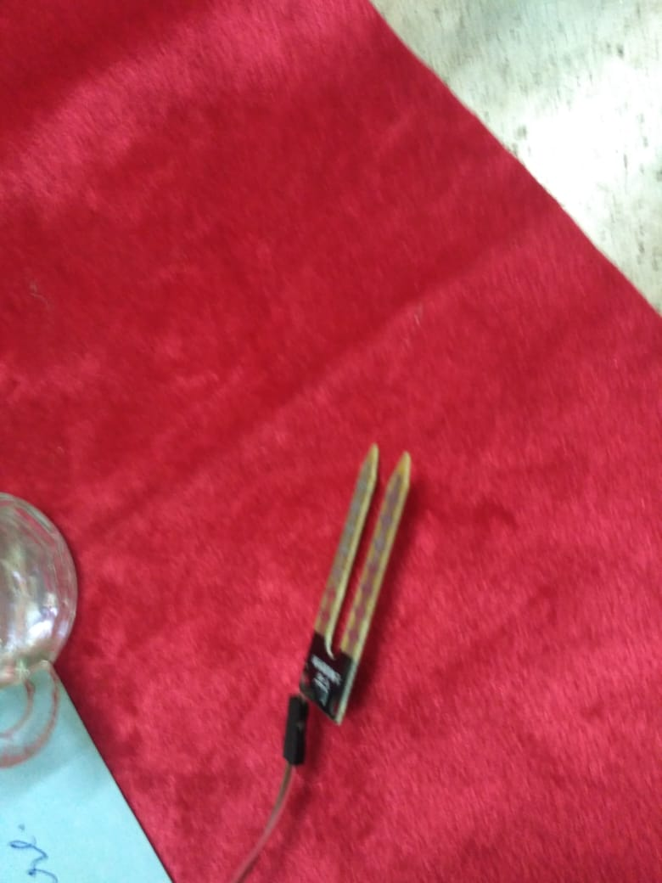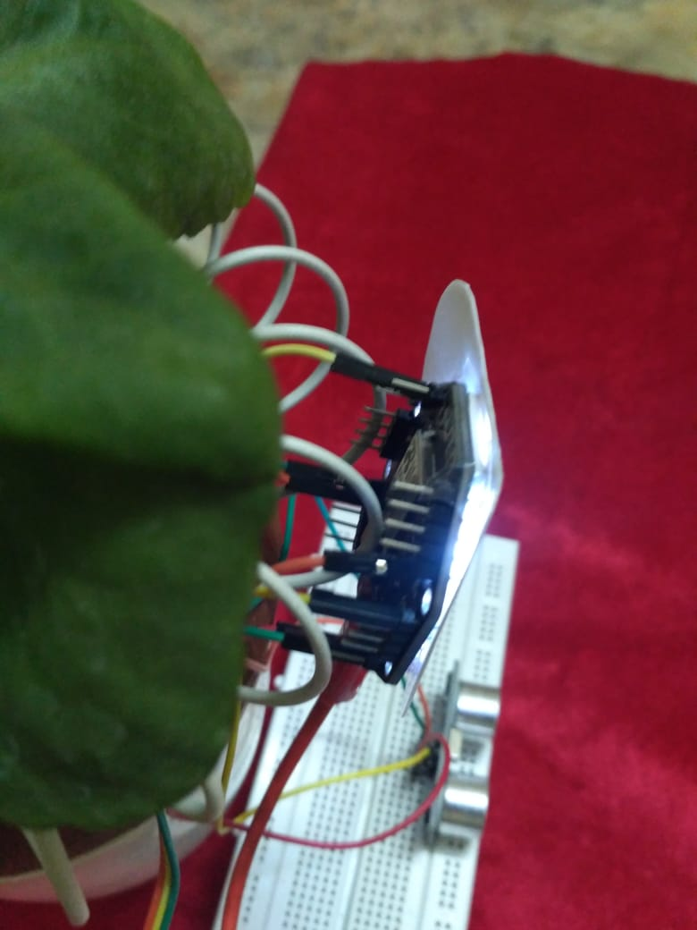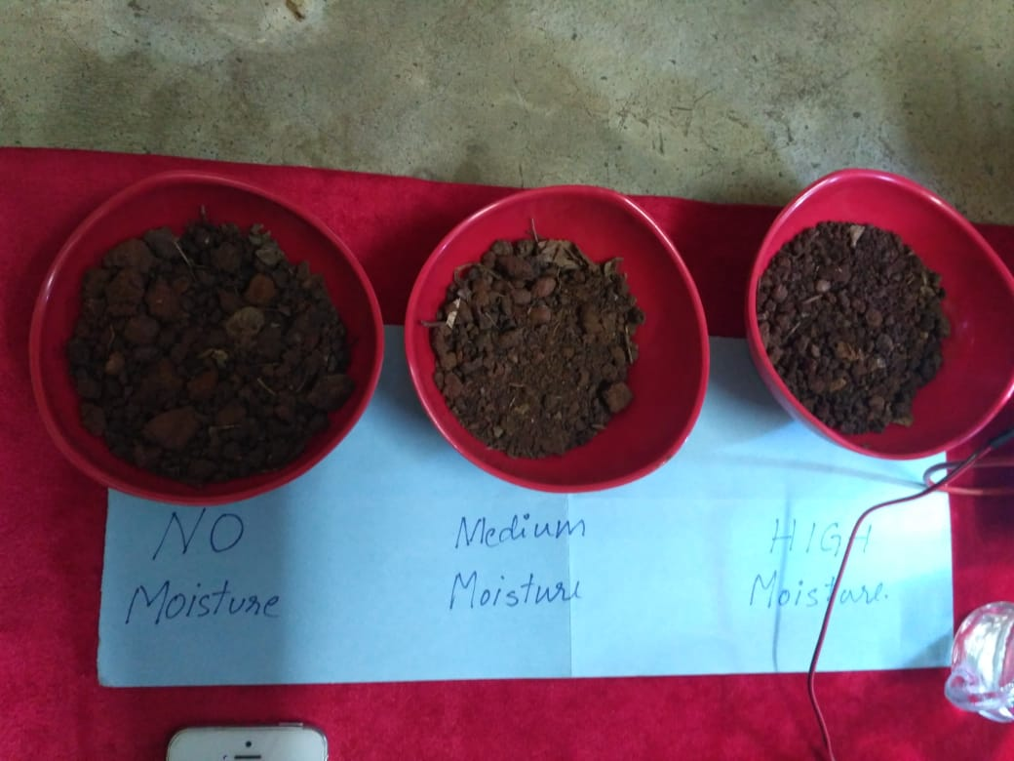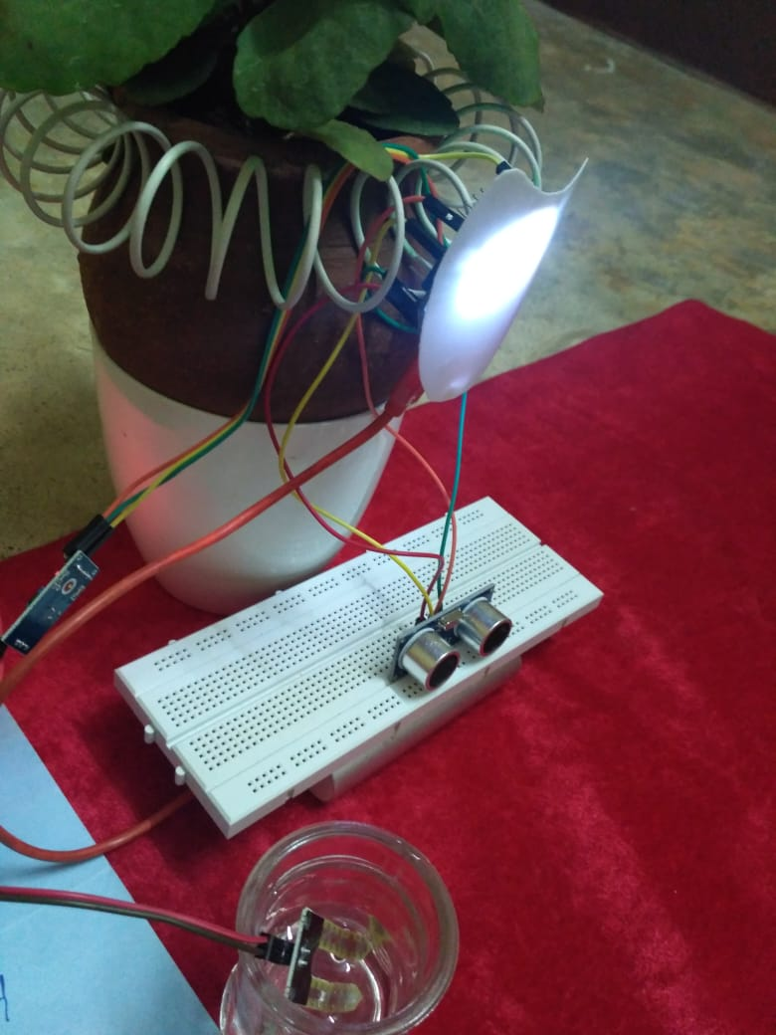

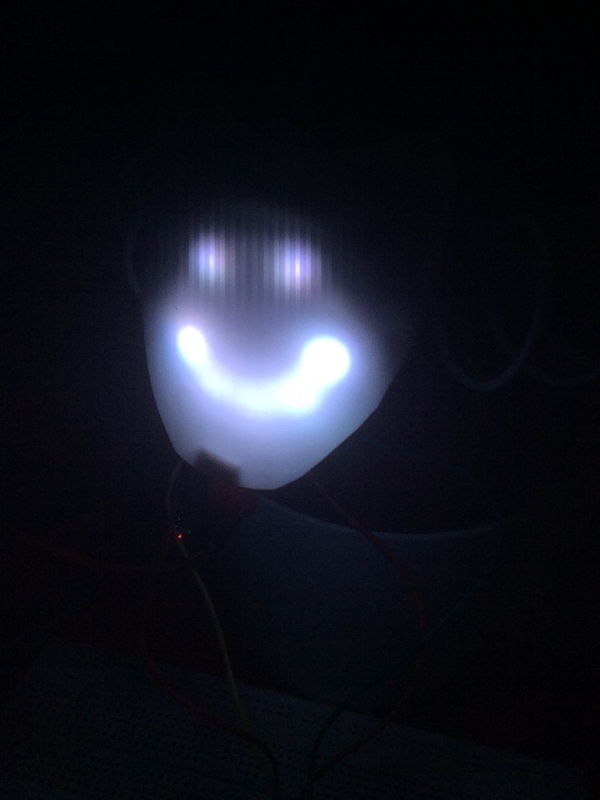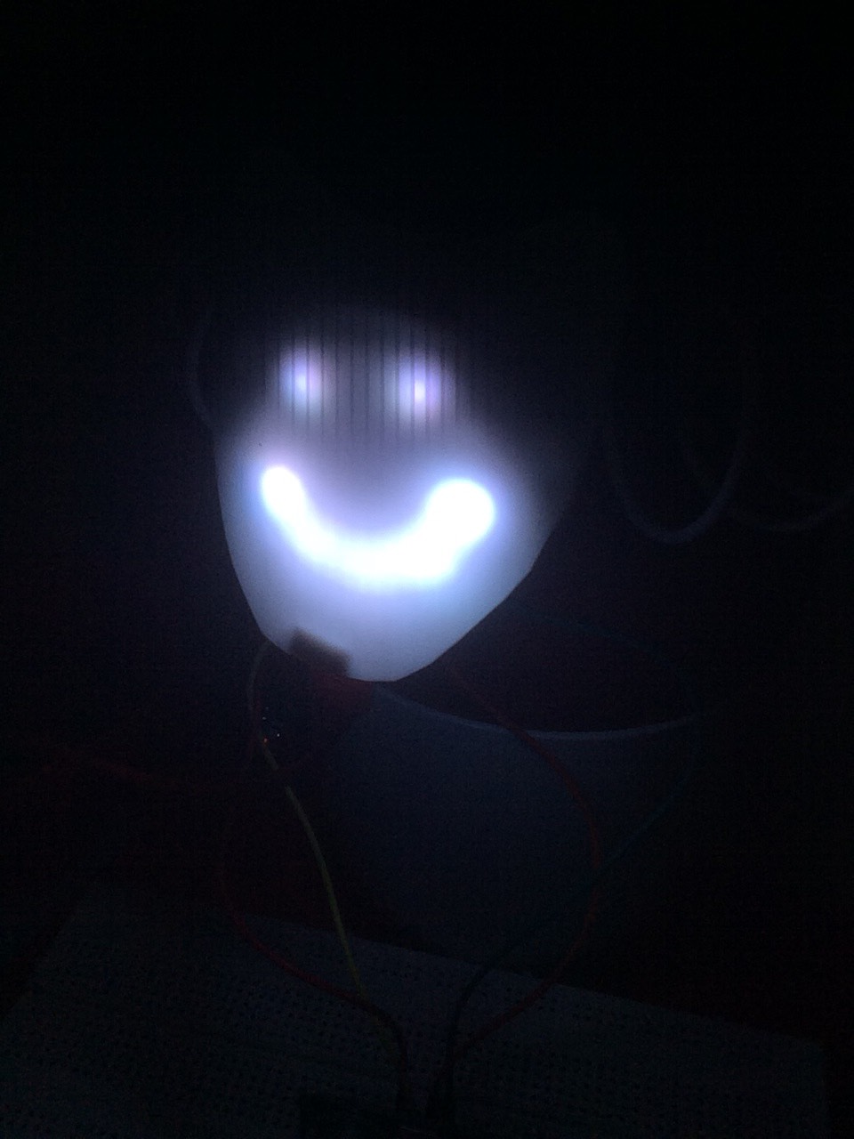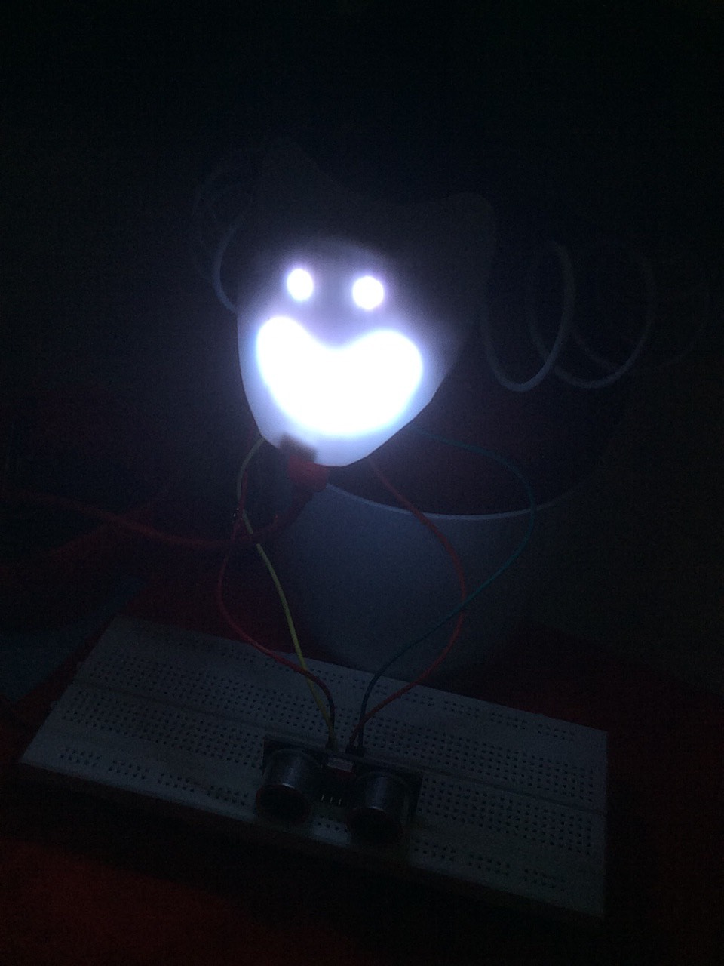

# Future scope of the project

# We’re planning on integrating with AI and machine learning so that the Smart garden assistant will be more intuitive and will respond organically to the individual's personality and behaviour.

# Constraints for real-time deployment

**Power requirement**

Development board itself as the power source for the sensors and actuators might be a constraint. As an alternative, external batteries can be used but in that case, the voltage has to be regulated in a proper way

**Transmitting data wirelessly**

The bin must transmit data to a cloud over Wi-Fi. When deployed in real time in cities which are not Wi-Fi enabled (most of them are not), there must be exclusive Wi-Fi connection for the bins. This might be a constraint in terms of deployment cost.

# References

* **IoT Based Smart Home Garden Watering**

**System Using Raspberry Pi 3**

Sandhya.B.R1, Pallavi.M2, Chandrashekar.M3

Assistant Professor, Dept. of ISE, Sri Krishna Institute of Technology, Bangalore, India1

Student, Dept. of ISE, Sri Krishna Institute of Technology, Bangalore, India2Student, Dept. of ISE, Sri Krishna Institute of Technology, Bangalore, India3